**NAME:** AROOJ NASIR

**ROLL NO:** FA24-BBA-080 (B)

**COURSE NAME:** PROGRAMMING LANGUAGE FOR BUSINESS ANALYTICS

**COURSE INSTRUCTOR:** MS MUFEEZA MANZOOR

**LAB ASSIGNMENT**: LISTS, TUPLES

TASK:01 TUPLES

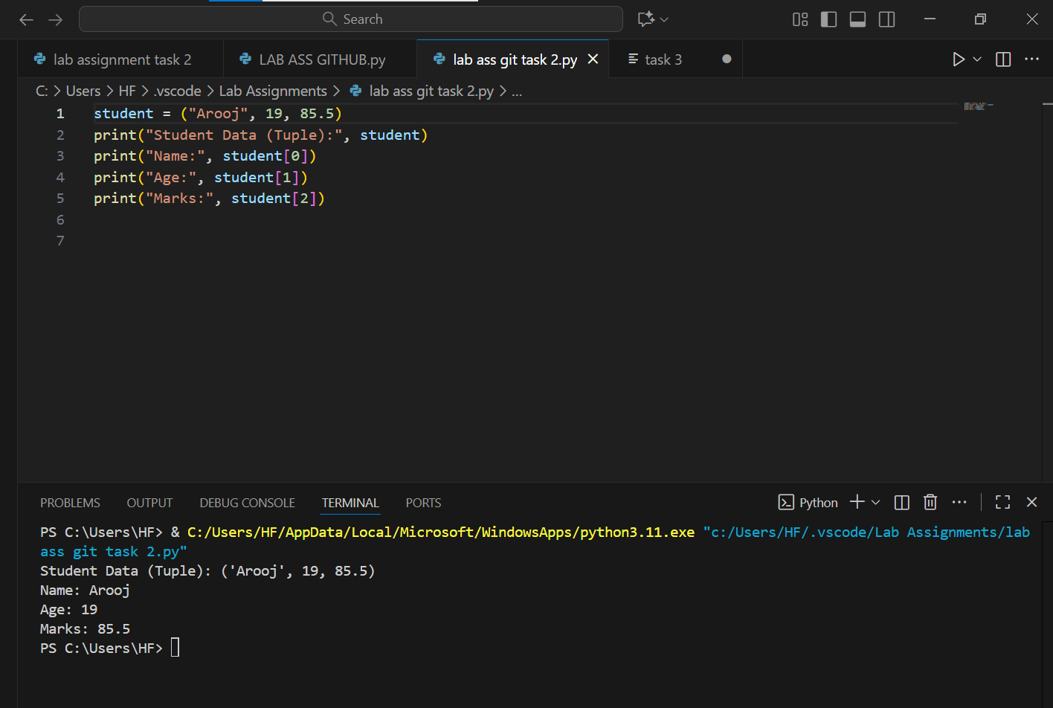

TASK 02:LISTS

